**Project Proposal**

Weather APP

Using a Agile Methodologies

By:

Karanbir Singh

Lovepreet Singh

Rajan Sharma

Gurjinder Singh

Harpreet Singh

Contents

Introduction 3

Agile Methodology 3

Wireframes 4

Main Page 4

ZIP Search 5

CITY SEARCH 6

Mockups 6

Main Page 6

ZIP Search 7

CITY SEARCH 8

Time Table 10

Testing 10

Functional Testing 11

Conclusion and Future Work 12

# Introduction

This project is about the weather application created by a group of 5 people. The application works in two ways. The first option is the ZIP search and the Second option is the city search. At the starting of the application, the clock with the current time appears, and the ZIP search and the City search option are below the clock.

# Agile Methodology

In this project, the Agile approach is being used as an alternative to conventional methods. This strategic approach is highly successful and realistic, and addresses the technology's evolving needs.

Our group has used the agile / scrum methodology in this project. At first, all requirements are specified and fulfilled by the team members. The team then decided to implement the Weather application's special feature to suit the users ' needs.

There's been a lot of changes to make this software more user friendly. The software is available for users to use after all the updates have been developed.

# Wireframes

## Main Page

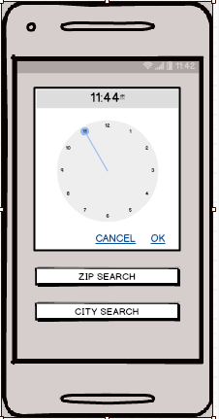

## ZIP Search

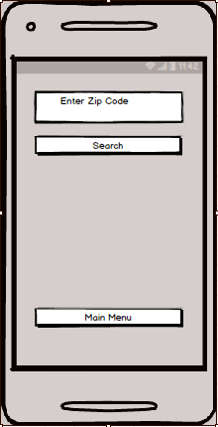

## CITY SEARCH

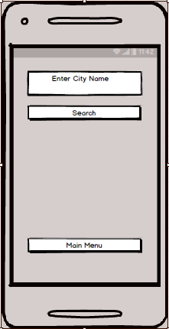

# Mockups

## Main Page

At the starting of the Application, an Analogic clock and a Digital clock appears with two button options that are ZIP and CITY Search button.

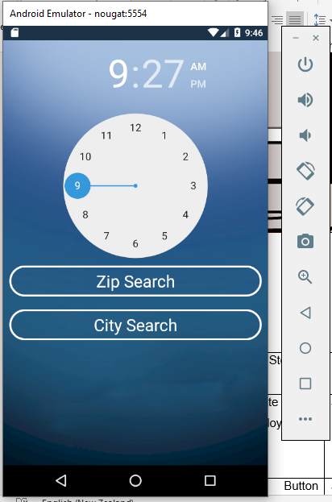

## ZIP Search

When Clicking on the Zip Search Button another page opens With Two-button options.

At the very top, there is a text bar Enter the ZIP code of any city and another page will appear with all the details as shown in the below picture:

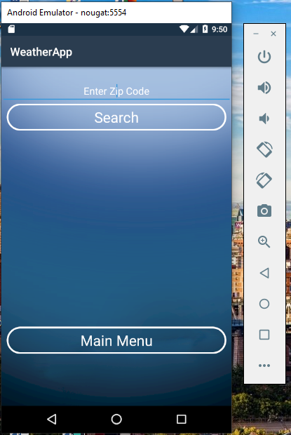

## CITY SEARCH

When click on the CITY SEARCH button Another page appears with a text bar at the very top. Enter the name of any city and another page will appears With the Details as shown in the Picture Below:

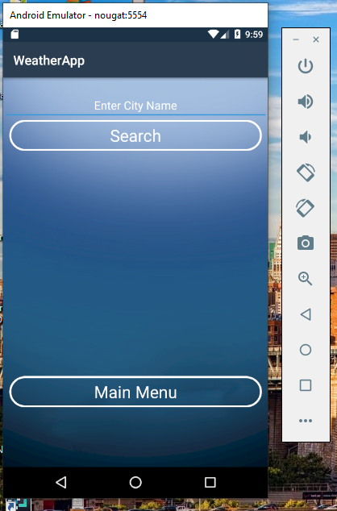

# 

# Time Table

|  |  |
| --- | --- |
| Task | Time |
| 1. planning | 4 days |
| 1. Wireframes | 7 hrs |
| 1. Home page | 2 days |
| 1. Information Page | 3 days |
| 1. Weather Page | 3 days |
| 1. mapping | 1 hour |
| Total | 12 days 8 hours |

# Testing

Due to the limited time available, we just conducted the usability testing and functional testing of the project out of which can be found at [Usability Testing.xls](Usability%20Testing.xls), and functional testing is mentioned below.

## **Functional Testing**

|  |  |  |  |  |  |
| --- | --- | --- | --- | --- | --- |
| **Step NO** | **Test Step** | **Input Data** | **Expected Result** | **Actual Result** | **Test Step Result** |
| 1 | Can Change the time of clock | Put any time | Time Should be updated | As Expected | Pass |
| 2 | Click on ZIP Search Button |  | New page opens with New options About ZIP search | As Expected | Pass |
| 3 | Enter the zip code of any city | 2102 | All Details About the weather of that city appears | As Expected | Pass |
| 4 | Click CITY SEARCH Button |  | A new page should appear  On the Screen | As Expected | Pass |
| 5 | Enter the City name | Auckland | All the details about the Weather of Auckland city should appear | As Expected | Pass |

# Conclusion and Future Work

In short, this project is built on an agile scrum approach in which the IT group has developed the so-called Weather application. Due to the limited time, we just build a small application. However, this application can be further improved, and more features can be added.